Big Mountain Resort wants a new way of determining ticket prices for it’s resort. They believe they are not capitalizing on their resort amenities as much as they could be. We attempt to implement two models to determine which one would be best to determine a new ticket price for Big Mountain Resort.

After modeling a linear regression and a random forest regressor, we found the random forest regressor gave us lower errors in our prediction and we will use this model to predict the price. When inputting information on Big Mountain Resort, our model determines the new ticket price for the resort should be $95.87. This is an increase of $14.87 on top of the original price of $81. Using the expected number of visitors, 350,000, and the average length of stay per visitor, 5, we see that this increase in price will give us an additional $26,022,500 in revenue for the resort to use as they will. The original problem that caused this was building a new chair that increased operating costs by $1,540,000. With this increase in revenue, it will be able to cover the increase in operating costs and provide an extra $24,482,500 in revenue on top of what the resort was making previously.

Our model also gives us information on which features have a higher impact on ticket price, which can be seen in the chart below. fastQuads and the number of runs a resort has is a huge impact on the ticket price.

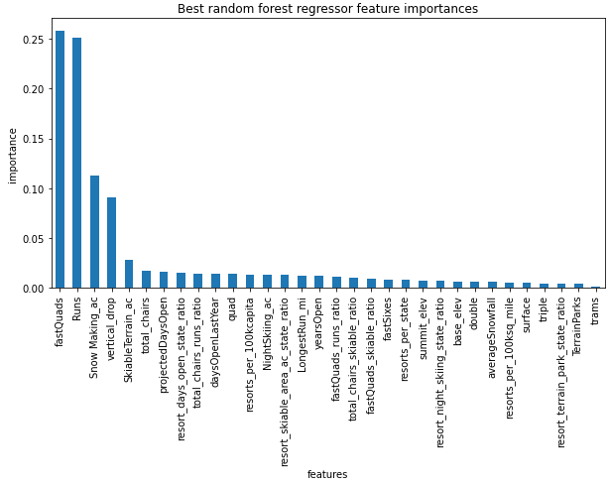

We have seen what our ticket price should be based on the current condition of the resort but Big Mountain has also provided some scenarios to be evaluated. Starting with scenario 1, which was to close down the 10 least popular runs at the resort. This scenario may be a good idea but there is not enough information to make an informed decision whether to implement this or not. The number of runs was the second most important feature our model found, closing runs will have a negative impact on the ticket price, as seen below. To further determine whether this is a good idea, we would need to know the cost to keep each run open so see if it will offset the decrease in revenue.

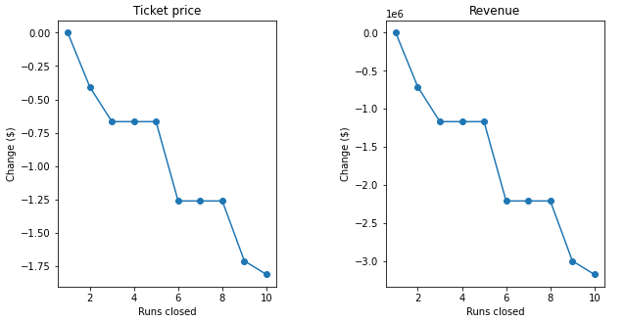

Scenario 2 adds a new run, increases the vertical drop by 150ft and adds a new chair. Inputting these changes into our model tells us that our ticket price will increase by an additional $8.61. This increase will offset the maintenance cost of the new chair, which we know based on the original problem given to us, and give additional money for the resort to use. Scenario 3 is the same as scenario 2 but it will also increase the amount of snow covered terrain by 2 acres. Scenario 3 will increase ticket price by $9.90. Which similarly to scenario 2, will offset the maintenance cost of the new chair and give additional revenue for the resort to use.

Scenario 4 was to increase the longest run and increase the amount of area that produces snow. This change prompted no increase in our ticket price so this scenario should not be implemented. Since it will cost money to implement this but it will not help bring back much in return.

In summary, our model suggests the ticket price should be increased to $91.84 which is more than enough to offset the new maintenance costs and capitalize on the features the resort provides to its guests. Of the scenarios provided, scenario 2 or 3 should definitely be looked into implementing and scenario 1 will need more information to determine if it is a good idea to implement.